MEMBERSHIP FORM

ALL MEMBERSHIP CATAGORIES £15.00

Mr Mrs Miss Ms (delete as appropriate)(**PLEASE USE CAPITAL LETTERS**)

Forenames………………………………………………………Surname…………………………………………………………………..

Address……………………………………………………………………………………………………………………………………………….

…………………………………………………………………………………………………………Post Code……………………………….

Email…………………………………………………………Telephone…………………… Mobile……………………………………..

**Please complete all areas of this form and return to:** [**membership@haods.org**](mailto:membership@haods.org)

**I have paid my membership fee by Bank Transfer Cheque in person**

Subscriptions for Membership to HAODS cover a year, or part thereof,

from May 31 to following June 1

**Please pay directly into HAODS bank account:**

Henley Amateur Operatic (HAODS)

Sort code: **20 39 53**, Account No: **30455288**

Please use reference “Membership”

**Alternatively, please send your cheque made payable to HAODS to**:

Bryan Villars, Treasurer, HAODS.

Chiltern View, Cook Lane,

North Stoke, Wallingford, OX10 6BG

Please email [membership@haods.org](mailto:membership@haods.org). to confirm you have paid and by which method

_____________________________________________________________________________________________

**Tell us a little bit about yourself:**

Acting age range: 16 –25 : 26 – 35 : 36 - 45 : 46 – 55: 56 – 65 over 65 ο

**Please indicate areas that you are interested in**

Acting Singing Dancing Directing Choreography

Technical Backstage Admin Costume

Musical Direction Hair & Make Up Other *Tell us more!

Are you new to the area? Yes/No

|  |
| --- |
| If yes, tell us how you heard about us |
| Do you belong to any other societies? |
| What roles have you played previously |
| * Tell us more! Please tell us anything else about yourself that you feel relevant! |

**DECLARATION: I hereby apply to join Henley Amateur Operatic & Dramatic Society (HAODS) and agree to abide by its rules, a copy of which is available on request. I also consent to personal data relating to myself being held on computer files and used by the committee for HAODS business.**

Signed……………………………………………………………Date…………………………………………………

**GIFT AID DECLARATION**

I declare that I pay Income Tax and wish to support HAODS, REGISTERED Charity 259404, and request that all subscriptions be treated as Gift Aid Donations until I notify otherwise.

Signed……………………………………………………………Date…………………………………………………

**About HAODS**

**Officers and Committee 2024 – 2025**

**President**

Simon Williams

**Committee Chair:** Julie Huntington[chair@haods.org](mailto:chair@haods.org)

**Vice Chair:** Alex Staunton [vicechair@haods.org](mailto:vicechair@haods.org)

**Hon Treasurer Hon Secretary Membership Secretary**

treasurer@haods.org[secretary@haods.org](mailto:secretary@haods.org) [membership@haods.org](mailto:membership@haods.org)

Bryan Villars Clancey Smith Samantha Riley

Ann Jenkin [ann@haods.org](mailto:ann@haods.org) Hugh Legh [technical@haods.org](mailto:technical@haods.org)

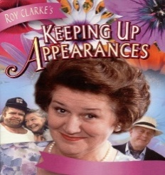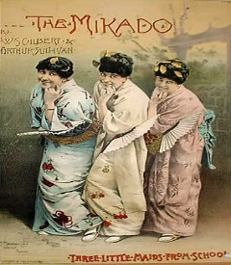HAODS was formed in 1922 with a sellout production of G&S's The Mikado, which was performed in the then cinema, The Regal. Things have certainly moved on since those days, and now HAODS performs large scale musicals in The Kenton Theatre. We celebrated our 2022 centenary with an award-winning version of G&S's Hot Mikado. Henley Amateur Operatic and Dramatic Society (HAODS) is an amateur dramatic society based in our studio in New Street in Henley-on-Thames.

We perform two full scale musicals in the Kenton Theatre each year and several smaller, intimate shows in The HAODS Studio per annum including our annual spring dinner theatre productions, catered by local restaurateurs. 2025 sees our seventh annual sell-out production, *Keeping Up Appearances.* Previous productions have included *Black Adder, Allo Allo, Hi Di Hi, Are You Being Served, Blackadder – The Whole Damned Dynesty, & Allo Allo 2*. These productions are the best of fun and extremely rewarding for the actors. HAODS is a member of the National Operatic & Dramatic Association (NODA). NODA gives us a constructive critique of each show and nominates societies for awards. HAODS also enter a one act play into three Drama Festivals in the area annually, Henley, Wallingford, and Abingdon. HAODS is often highly successful at these.

We also submit at least one of our studio productions to the annual Henley Drama Festival and often tour around local Oxfordshire drama festivals. Due to our success, we have been invited to compete in the National Drama Festival on several occasions, including this year.

We are registered with The National Operatic and Dramatic Association (NODA) and have been nominated for and won many awards for our shows, including Half a Sixpence, Jesus Christ Superstar, Our House, Shrek, and The Hot Mikado.

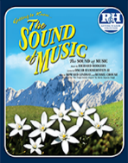We welcome new members, both on stage and behind the scenes, and encourage newcomers to the performing arts, giving them confidence and life skills that being a part of a team develops.

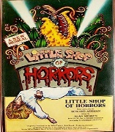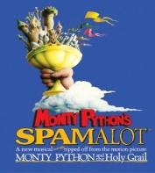

HAODS is a registered Charity No 259404